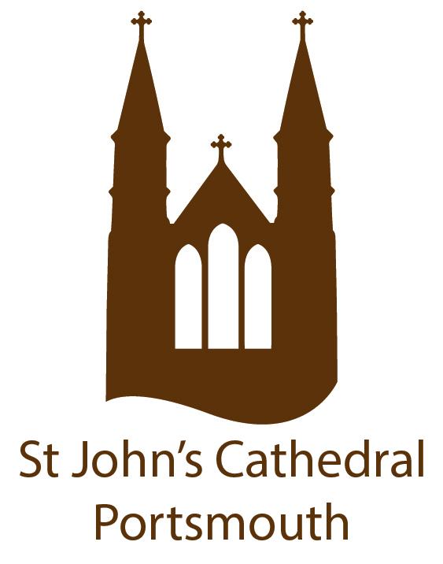
APPLICATION FORM FOR FIRST HOLY COMMUNION 2021
For children in Year 3 or above
Our programme is only open to children already baptised Catholic who belong to the Cathedral parish either through registration or by residing within our boundaries and who are born on or before 31.08. 2014. Please complete this form in BLOCK CAPITALS and return to the Parish Office.

Child’s Details:
Surname: _________________________ Christian Name (s) _________________________
Date of Birth: _____________________ Male/Female: ____________________________
Address: ___________________________________________________________________
Post Code: _________________________
Date of Baptism: _______________ Church of Baptism: ______________________________
[You must include with this application a copy of your child’s baptism certificate]
Name of Child’s present School: __________________________ Year Group: __________
Does your child have behavioural, medical or physical needs that we should be aware of?
Yes/No If ‘yes’ please state what those are:

Parent/Guardian Contact Details:
Mother’s Name: ____________________________ Religion: _______________
Address: (if different from child’s): __________________________
Contact telephone numbers: _____________________________________________________ PTO
Email address: (this will be used to correspond with you throughout the First Holy Communion programme) ______________________________________________________
Father’s Name: ________________________________Religion: _______________________
Address: ___________________________________________________________________
Contact telephone numbers: ____________________________________________________
Email address: (this will be used to correspond with you throughout the First Holy Communion programme) ____________________________________________________
Alternative Contact Details:
Name: ___________________________________________________________________
Address: __________________________________________________________________
Contact telephone numbers: __________________________________________________
Mass Attendance:
Which Sunday Mass in the parish do you usually take part in? _________________________
How regularly do you attend Sunday Mass? Weekly/Fortnightly/Monthly/Less often
The programme donation to cover costs is £20 per child. Cash or cheque is acceptable. If paying by cheque please make cheque payable to ‘PRCDTR – Cathedral’. Please place your cash/cheque in an envelope clearly marked First Holy Communion 2021 and your child’s name and post through the Parish Office letterbox door. Fully completed forms must be returned to the Parish Office with a copy of your child’s Baptismal certificate by 12 noon on Friday 31 January 2021.

Dates, times and venue of both First Holy Communion sessions and Parents’ Meetings will be provided once all necessary arrangements have been confirmed.
Signed: __________________________________________Date: _____________________
Printed Name: ____________________________________
Protecting your privacy – Your personal details will be stored and used by the Parish for the purposes of conducting and administering the Sacrament of First Holy Communion.
I /we consent to my/our details being used as above.
Signed: __________________________________________ Date: _____________________
Office Use Only
Copy of baptism certificate Donation received

